Celebrating Saints-All Saints Day Activity by Marie Love
Grade 2
Activity found on Pinterest:
http://www.catholicplayground.com/saints-and-objects-matching-game/
Objectives:
2.3.13 give examples of service activities that can be shared with family, neighborhood, school, and parish.
2.4.1 give examples of how people demonstrate their love for Jesus through their roles and responsibilities within the family.
Room Environment: I would have this board displayed in our Prayer Space where we would talk about the different objects that link them with the Saint. I could also use this activity as a center and have an answer sheet that the children could check their answers once we were finished learning about all the Saints.
Materials:
*black foam board
* string for hanging the objects
*”s” hooks
* color pictures of the saints-we specifically chose images of the saints that did not show their objects, to make the game a little more challenging
*objects associated with each of the saints
*pictures of these objects
- St. Agnes (lamb)
- St. Andrew (X-shaped cross)
- St. Blaise (two small candles crossed)
- St. Catherine Laboure (miraculous medal)
- St. Cecilia (harp)
- St. Clare (monstrance)
- St. Dominic (one decade rosary)
- St. Elizabeth Ann Seton (chalkboard)
- St. Francis of Assisi (wolf)
- St. Francis Xavier (crocodile)
- St. Helena (cross)
- St. Ignatius of Antioch (lion)
- St. Joan of Arc (armor, helmet, sword, and shield)
- St. Juan Diego (tilma)
- St. Joseph (hammer)
- St. Longinus (spear)
- St. Patrick (shamrock)
- St. Peter (key)
- St. Therese (rose)
- St. Veronica (veil)
- St. Zita (bread)

**I might look through our Religion book and adapt the activity to the Saints that are presented in our book.
This picture is of what the finished board would look like. Obviously, this is just a few of the pictures.
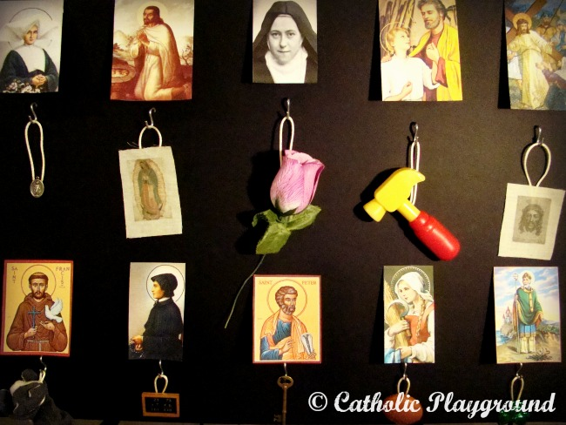
Description of the Lesson
The reason I chose to do this activity was because during a field trip to the Shrine at the end of the year, I realized that my students did not know as much about Saints as I wanted them to. When we went to the Shrine, the Priest asked the children questions about Saints and what items they are seem with and to my surprise my students did not know the answers to several of those questions. I found this activity online, however I will add to it. At the beginning of the school I plan on having this activity present in the room. During each Religion lesson, I will focus on a Saint from our board and discuss a little about their life of service to God and the object that is significant to them. I will use Bible stories, Saint books, our Religion book and videos to discuss the Saints. I plan on having discussed all the Saints on our board by All Saints Day. For All Saints Day, I would like for each student to choose a Saint, research them, and then dress up like the Saint. Each student will present their Saint to the class, as well as have a written report on the Saint. At the end of our lesson, I will make copies and bind all the Saint reports in a book for each student to have as a keepsake. I thought about this activity last year after the day had passed, but I am looking forward to trying it this year. I also, think it would be nice to visit other classrooms to give their report about the Saint, as a form of service to our school. It is important for my students to know that most of these people became Saints because of their lives of service to God or that they died for their Religion.

