Creating a Shared Document in Google Drive
Diocesan Technology Seminar • 16 January 2014
Mary Lynn Delfino • mdelfino@kent.edu

Step 1
Sign in to your Gmail account and access Google Drive.

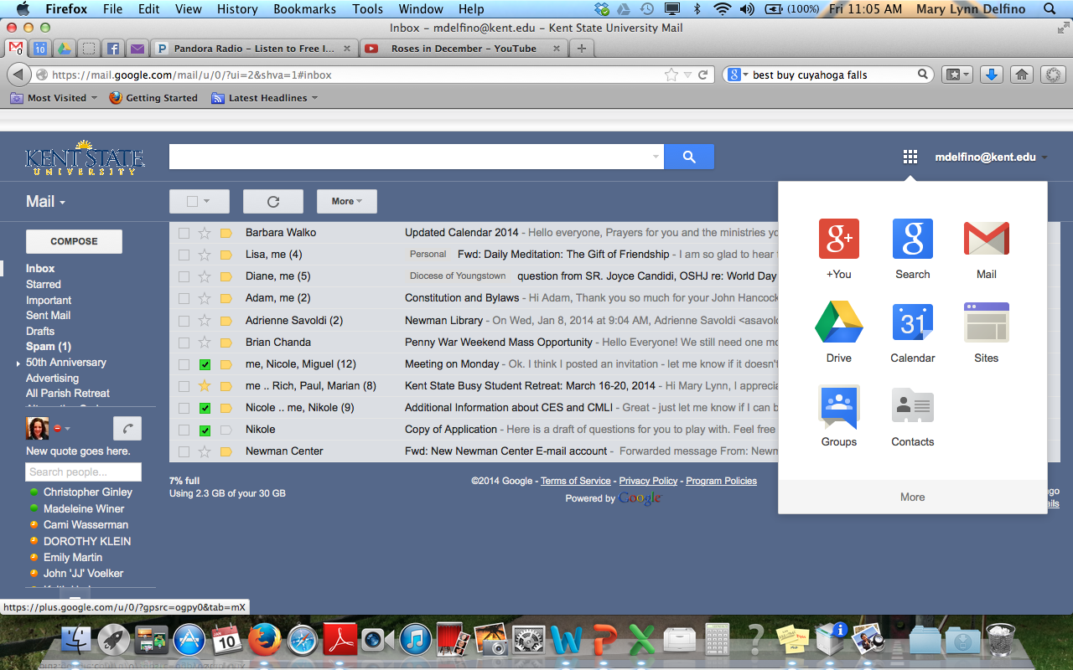

Step 2
On the left side of the page, click Create and select Document from the drop down menu.

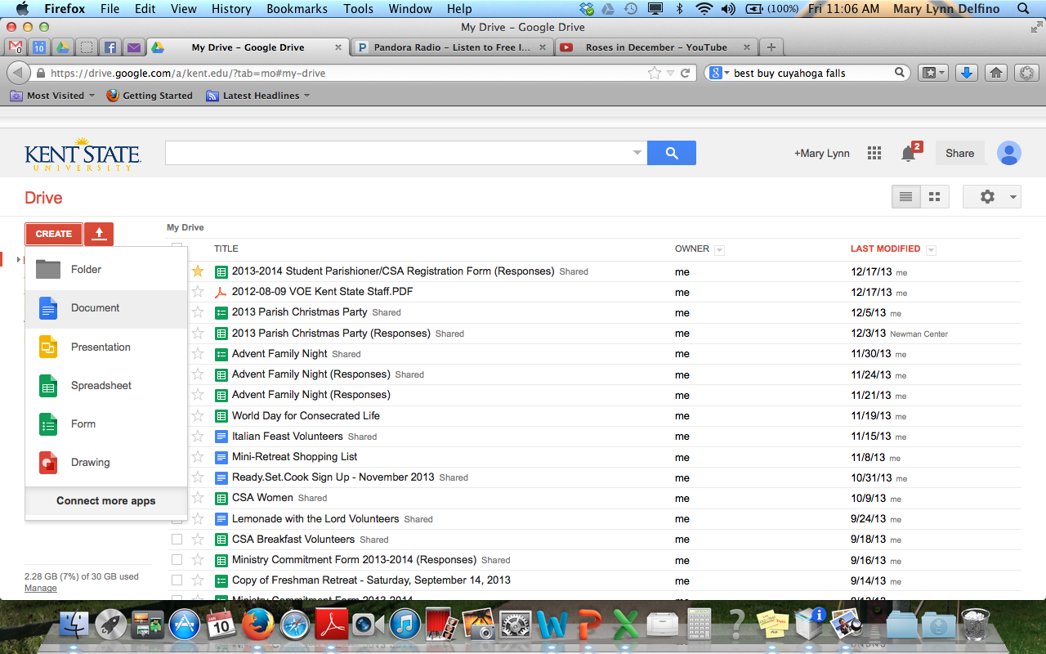

Step 3
Type the body of your document. To name your document, click the grayed out box Untitled Document in the upper left side of the screen.

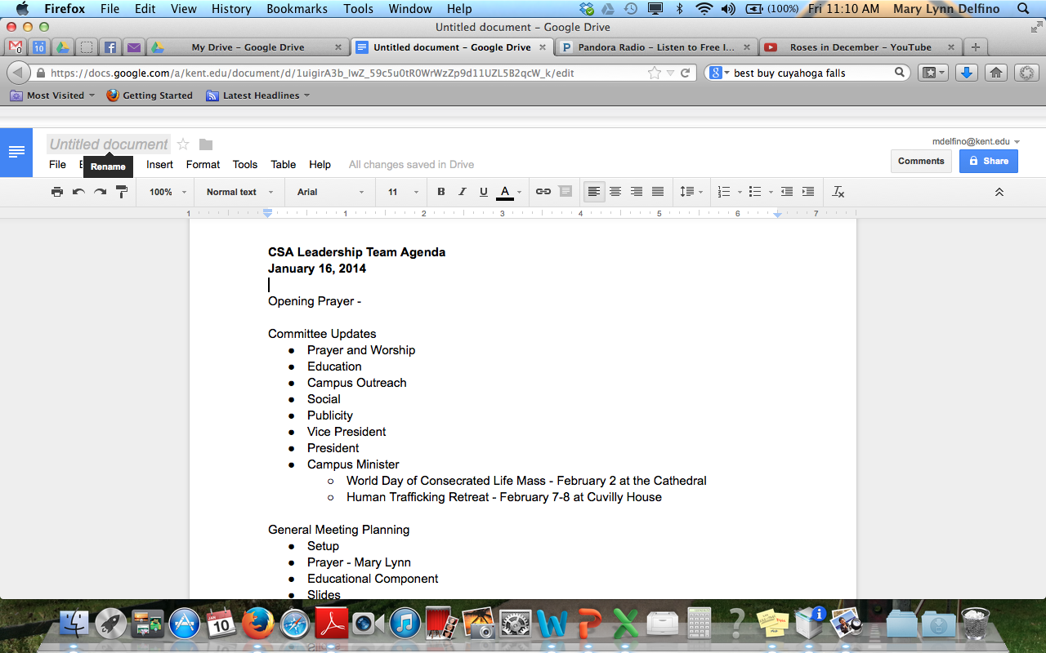

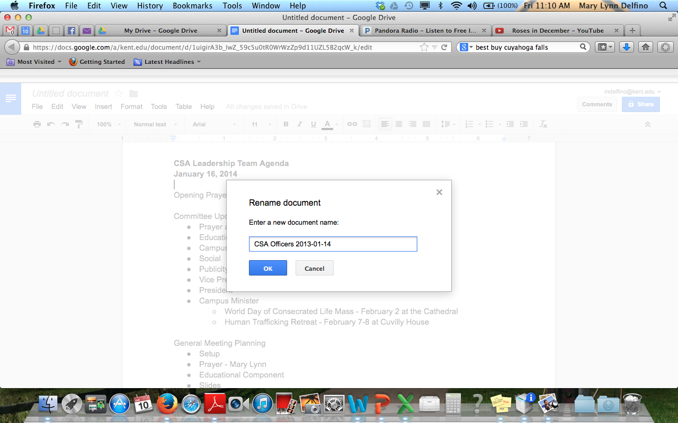

Step 4
To share the document with others, click FileShare. The following dialog boxes will appear.

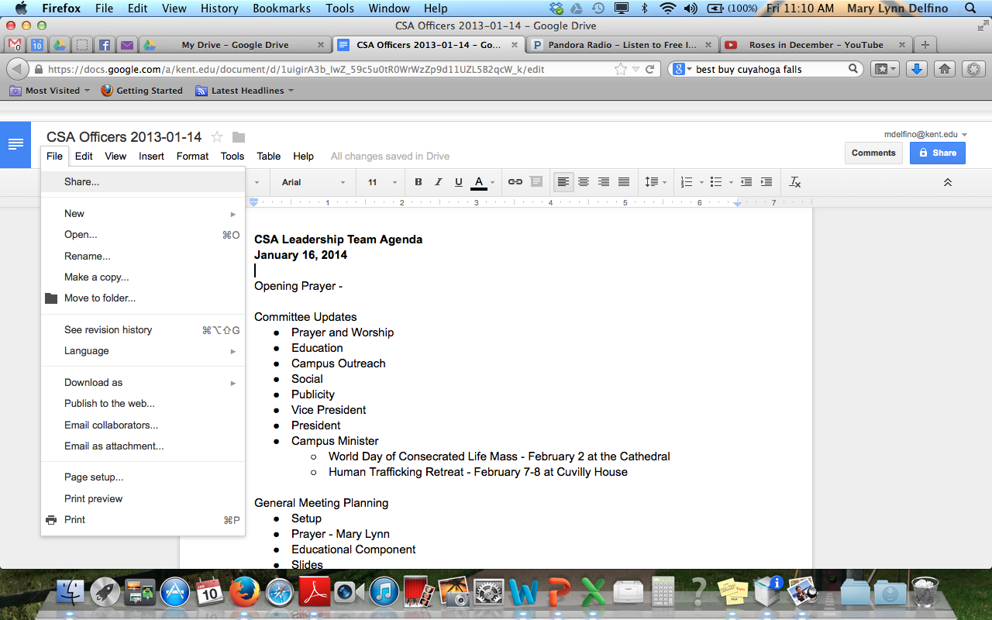

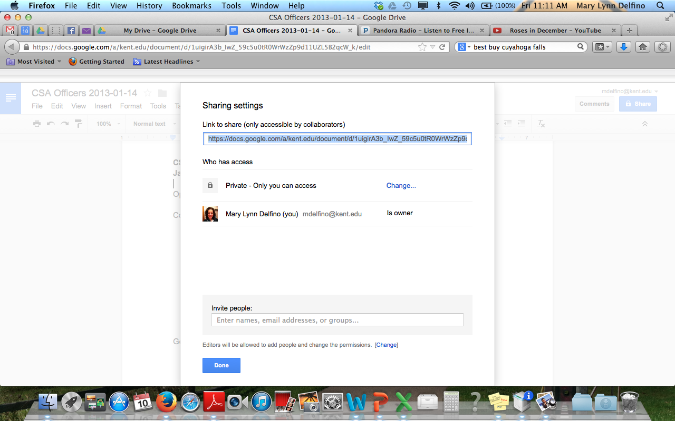

As the creator of the document, you have control over who can view and edit the document. These settings are found under Who has access.

Step 5
Decide what privacy level you desire for the document. In this example, I only want to share the document with people on my team, so I am going to keep the Private setting; however, even with the Private setting I need to invite people if I would like them to be an editor using the dialog box at the bottom of the screen.Notify people via e-mail and type a message (optional). This message will appear in their e-mail with a link to the document, so it’s a good way totell people why they should open the file. Click Share & save to complete this process.

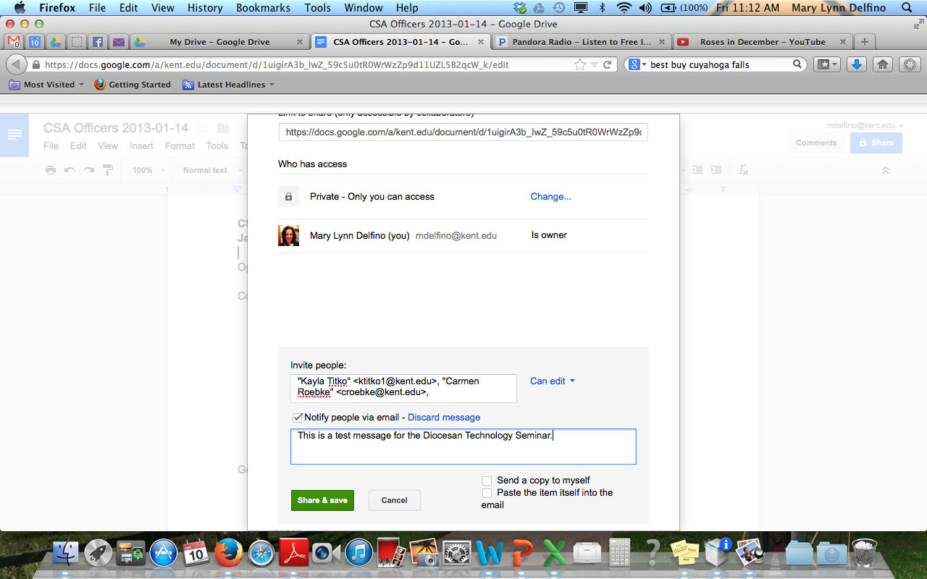
Drive will populate names from your Contacts.

Step 6
Review privacy settings and make changes to individuals as necessary and click Done.Get ready for some good collaboration with your team members.

Troubleshooting tip: Here you can change settings for individuals. Google often defaults to Can view. Be sure that Can edit is checked if you want people to be able to contribute to the document. Here you can also delete collaborators or add new people by clicking File Share at any time.

