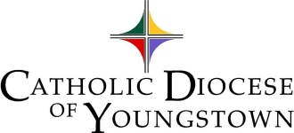
Office of Faith Formation and Lay Ecclesial Ministry

CELEBRATION OF THE SACRAMENT OF CONFIRMATION 2021-2022

Please Print or Type

Parish City

Date of Confirmation

Confirmation Statistics

Number of Persons Confirmed: Grade 8
Grade 9
Grades 10, 11, 12
Total Youth
Adults (if any)

Number of potential candidates invited to your Confirmation preparation

Number of candidates who participated in your Confirmation preparation

Number who participated in the preparation, but were NOT confirmed

Please indicate any reason that may have contributed to candidates NOT being confirmed .

Please describe the preparation process for Confirmation at your Parish, highlighting the specific blessings and challenges.

OVER
2022

Confirmandi Including
only sponsors/parents?
Component Parts of Your Preparation Program

- Informational session

- Catechetical session on the
Sacrament of Confirmation and the Holy Spirit

- Catechetical session on Reconciliation

- Catechetical session on Initiation into the Catholic Church

- Rehearsal

Confirmation Preparation

Date(s)

Day(s) of the week Time(s) of sessions

Catechetical Resources

Title(s) Publisher(s)

Number of Adult Team Members

Catechists Advisors/Others

Form completed by: Name Position

Phone Date

Ashtabula, Columbiana, and Mahoning Counties,
please return to:
Margie Hynes
mhynes@youngstowndiocese.org
Portage, Stark and
Trumbull Counties,
please return to:
Barbara Walko
bwalko@youngstowndiocese.org

PLEASE COPY FOR YOUR FILE AND RETURN AT YOUR EARLIEST CONVENIENCE. THANK YOU!
2022
2021

