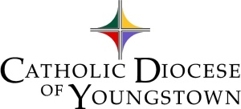
Office of Faith Formation and Lay Ecclesial Ministry

PERSONNEL REPORTS 2021 – 2022

Please submit a list of the volunteers for the areas within your areas of responsibility. Include the following:

Adult Faith Formation Contact or Chairperson
Adult Faith Formation Personnel or Team Members
Catechists for Spanish Speaking Adults

Confirmation Preparation Contact
Confirmation Preparation Team members

Elementary Catechesis Contact or Principal
Elementary Catechists (please include age, grade levels of their learners)
Elementary Catechesis Aides
Elementary Catechists for Spanish Speaking

Evangelization and/or Small Christian Communities Contact
Evangelization and/or Small Christian Communities Facilitators or Leaders

RCIA Contact Person
RCIA Team Members
RCIA for Children Contact

Special Needs Ministry Contact or Coordinator
Special Needs Ministry Catechists

Young Adult Ministry Contact
Young Adult Ministry Team Members

Youth Ministry Contact
Youth Ministry/Adolescent Catechists
Youth Ministry Team Members

Please include name, address, contact phone number, and email.
Use parish spreadsheet or use the attached.

RETURN AS SOON AS POSSIBLE
Ashtabula, Columbiana, Mahoning Counties Portage, Stark, Trumbull Counties

Margie Hynes Barbara Walko
Office of Faith Formation and Lay Ecclesial Ministry Office of Faith Formation and Lay Ecclesial Ministry
225 Elm Street 225 Elm Street
Youngstown, OH 44503 Youngstown, OH 44503
mhynes@youngstowndiocese.org bwalko@youngstowndiocese.org

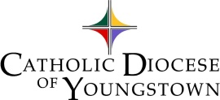
Office of Faith Formation and Lay Ecclesial Ministry Please identify which ministry these volunteers serve.

PERSON COMPLETING FORM

DEANERY PARISH/CITY MINISTRY

TITLE  Mr.,Mrs.  Sister | FIRST NAME | LAST NAME | ADDRESS | CITY, STATE, ZIP | PHONE | EMAIL ADDRESS | Grade/Age Level

PLEASE DUPLICATE THIS FORM FOR EACH AREA OF MINISTRY 2022

