Creating a Public Form on Google Drive
Diocesan Technology Seminar • 16 January 2014
Mary Lynn Delfino • mdelfino@kent.edu

Step 1
Sign in to your Gmail account and access Google Drive. Decide what format you would like to use for your form (a document, a spreadsheet or a Google form). For this example, we will use a spreadsheet. You can use a word document but spreadsheets are easier for getting quick numbers.

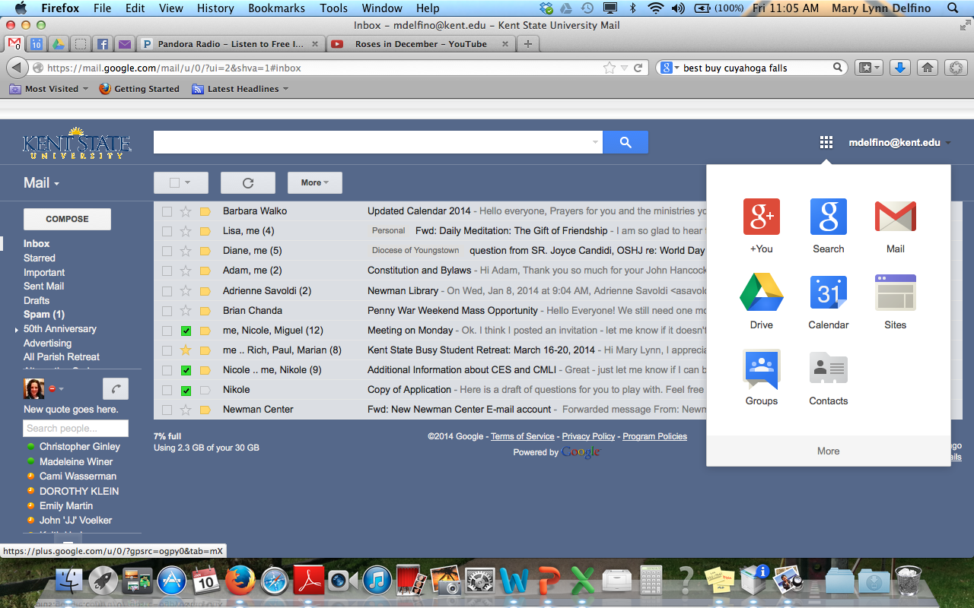

On the left side of the page, click Create and select Spreadsheet from the drop down menu.

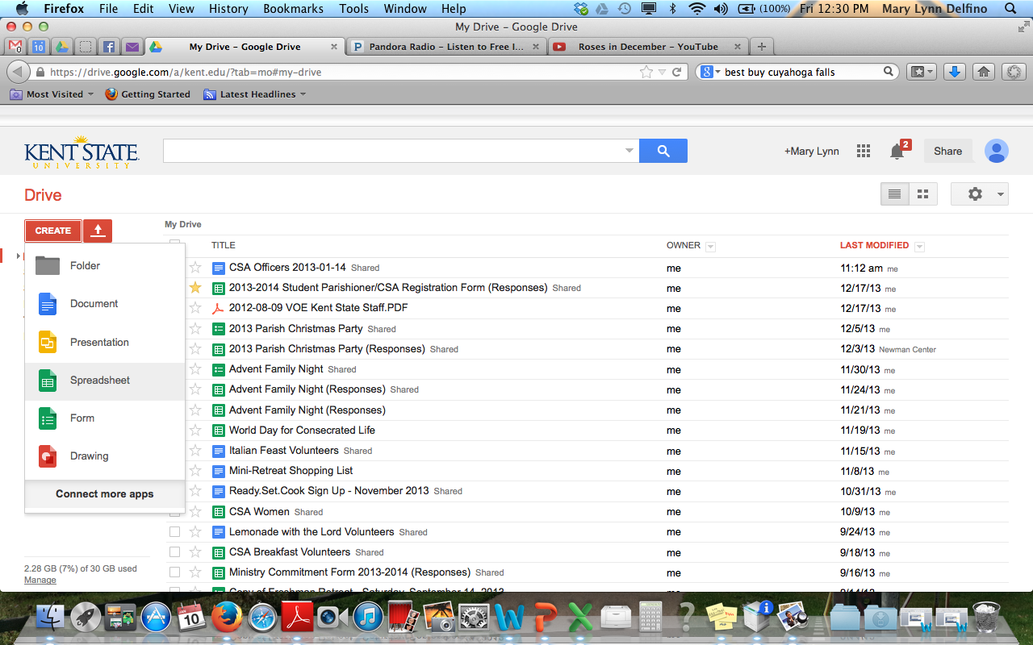
Step 2
Type the body of your document. To name your document, click the grayed out box Untitled Document in the upper left side of the screen.

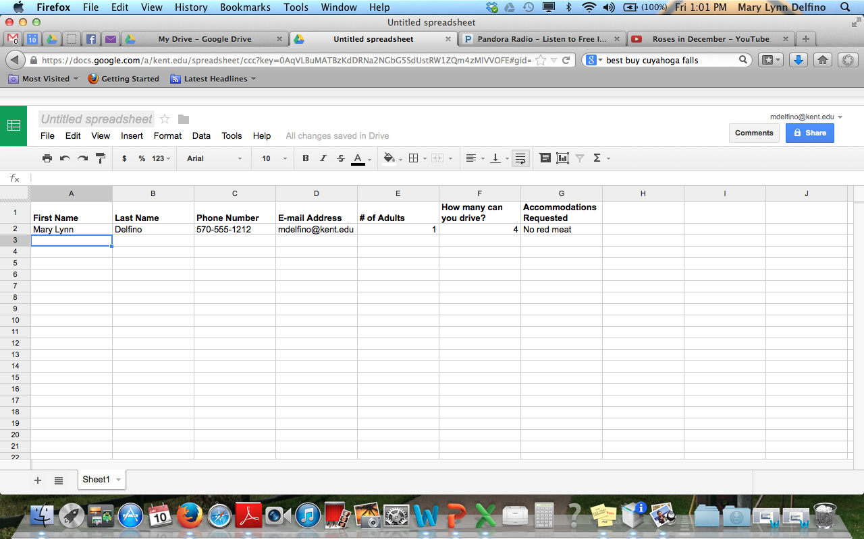

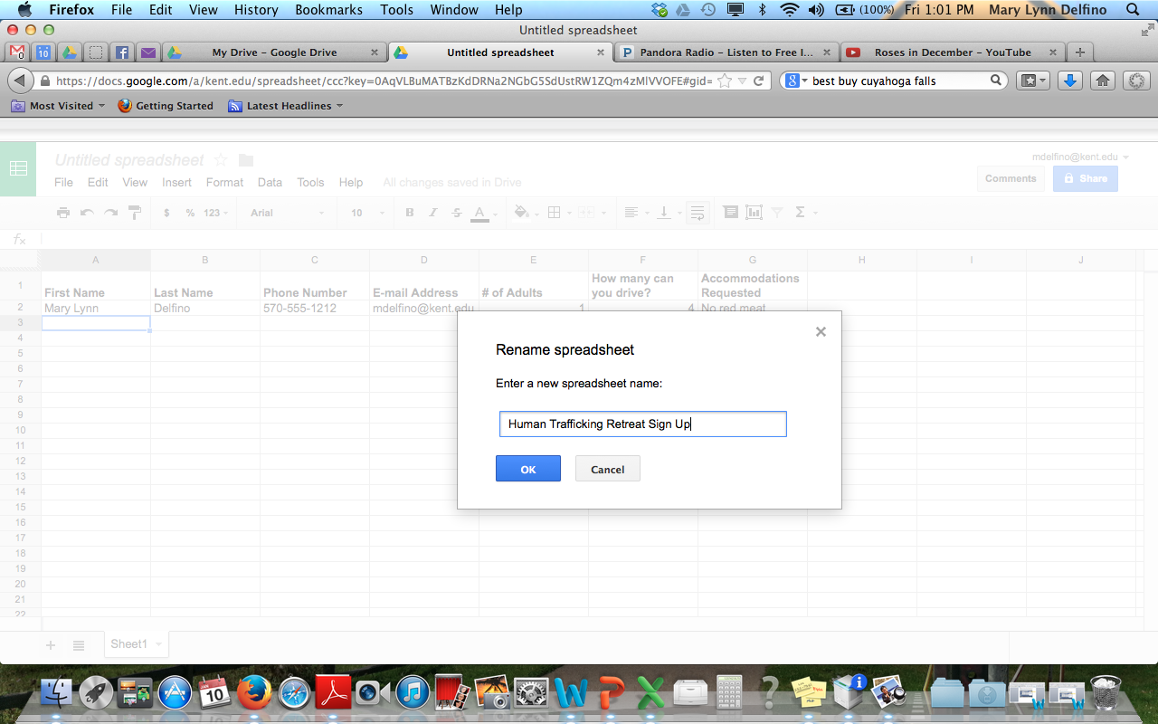

Step 3
To share the document with others, click FileShare. The following dialog boxes will appear.

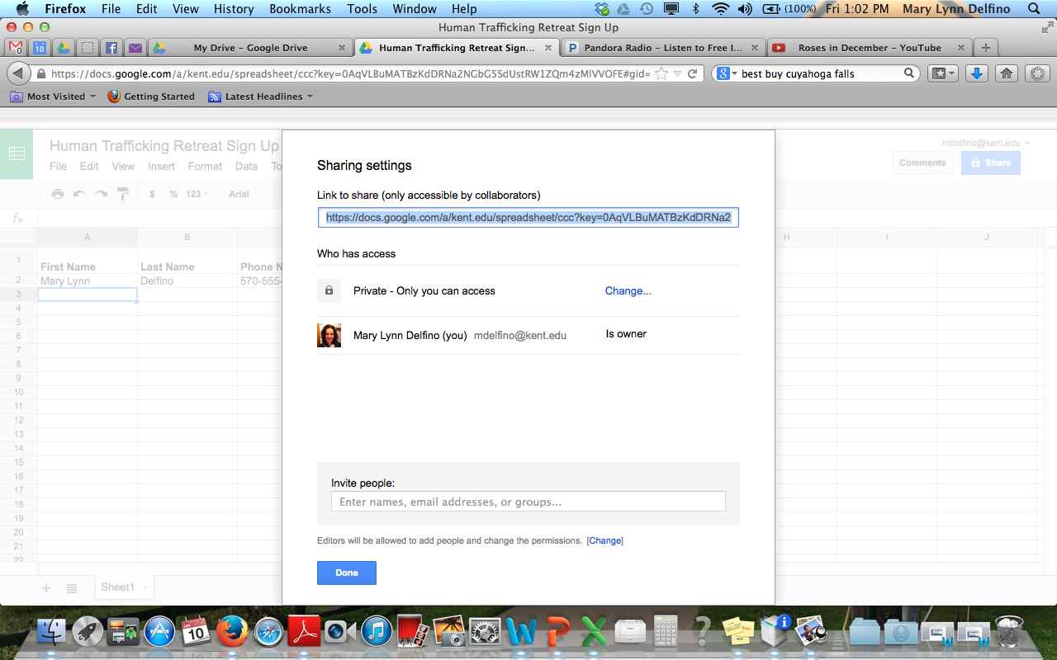

Because we would like anyone to be able to add their name to our registration list, we
need to change Who has access from Private to Public (note: your list may look slightly
different if you are not a Kent State user). We also need to change the Access to Can edit.

Troubleshooting tip: If you do not change this setting from Private, no one will be able to access your document. These settings can be changed at anytime by clicking File Share.

Step 4
Next, we would like to include another staff person who would like to keep track of participants. We do this by inviting people using the dialog box at the bottom. Notify people via e-mail and type a message (optional). This message will appear in their e-mail with a link to the document, so it’s a good way to tell people why they should open the file. Click Share & save to complete this process.

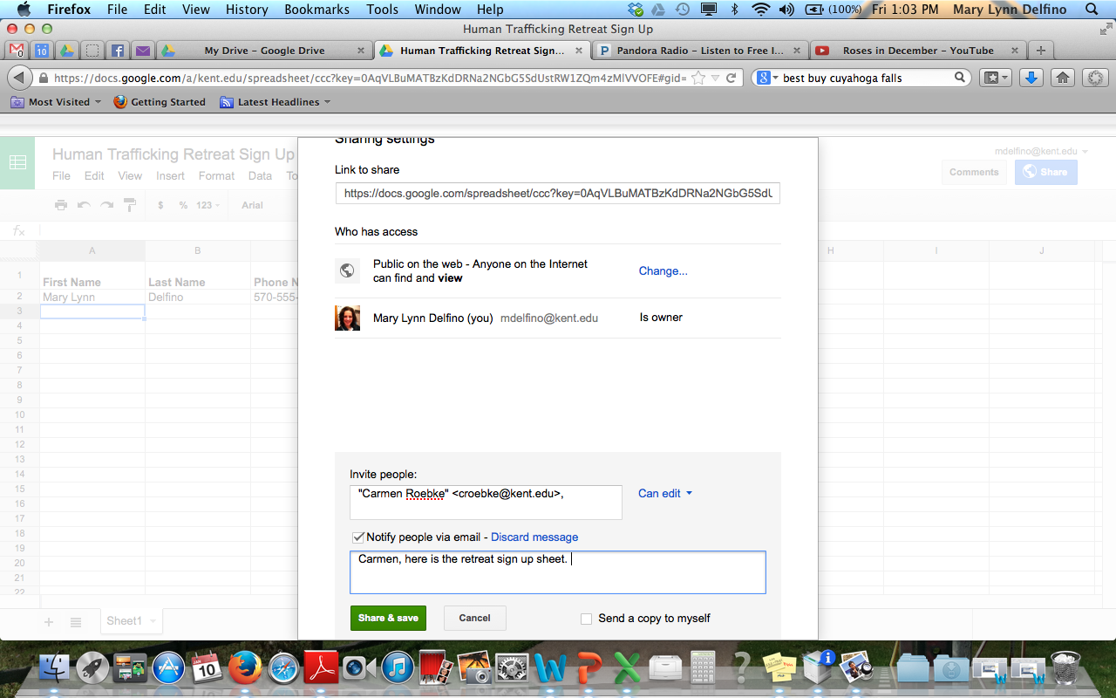
Drive will populate names from your Contacts.

Step 5
Review privacy settings and make changes to individuals (if needed) and click Done.

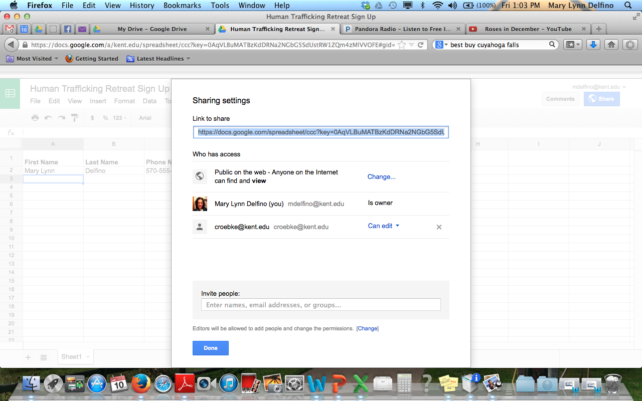

Step 6
In order for people to sign up, we need to send them the link. This link can be shared via e-mail, website or social media. Simply copy the Link to share at the top of the dialog box (Ctrl + C in Windows or Command + C in Mac) and paste (Ctrl + V or Command + V) in an e-mail, on your website or on your Facebook page.

