Noah’s Ark Lesson for First Grade Students

Learning Objective: Scripture - 1.1.2 Know that Bible Stories are different from other stories because they are God’s Word to people.
Old Testament 1.14- Recognize significant Bible characters and their stories, e.g., Moses, Abraham, Adam and Eve, etc.
Classroom Environment and seating arrangement
This lesson will take place over one week in the First Grade classroom. This will be one of the first Old Testament lessons taught to the students at the beginning of the school year. The students will work on coloring their arks at their seats. The students are seated in pods of 4 or 5 students.

Materials List
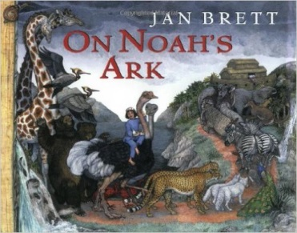
- On Noah’s Ark by Jan Brett
- Noah’s ark coloring page
- Animal coloring sheets
- Card stock
- Crayons
- Scissors
- Elmer’s Glue
- Large Ziplock bags
- Fruit Loops
- 18x24 piece of construction paper- 1 for each student.
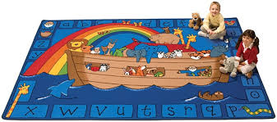
Description of Lesson

Monday- Read story to students and discuss. Also draw attention to the rug they are sitting on and how it tells the story of Noah’s ark.

Tuesday- Review the story of Noah’s Ark and explain how to color their boat and animals. (A link to the boat they will be coloring http://www.artistichandsoffaith.com/?p=917 ) Remind students that they should do their best at coloring not only the boat, but the animals too. Students who finish early may use their extra time to cut out animals and pieces of their boats.

Wednesday- Cut out animals and boat pieces. Assemble the boat. This will be a little difficult for some students. I and my assistant will be around to help the first few students. Once the students are finished making their own boat, they will go around to help other students. Completed boats and animals will be stored in large Ziplock bags until tomorrow.

Thursday-We will review the colors of the rainbow, and the correct order of them. We will also review why the rainbow is important in the story. The students will cut out the rainbow and glue the Fruit Loops onto it. Then they will glue their boat, animals and rainbow to the large piece of construction paper.

Friday- Once the students’ boats and rainbows have dried, we will place them on our bulletin board outside the classroom. We will also watch the Noah’s ark video from Youtube (https://www.youtube.com/watch?v=VeeNfVI0_TU )

