How to (s) for Power Point Presentations (Directions for 2010)

Click Start
Click All Programs
Click Microsoft Office
Click Power Point
The first page that opens has two fields on it that you can use for your title or you can remove.
If you choose to use the fields
Click inside the square and type your title
Jump to choose your style
If you choose to remove them
Click inside the square
Click the outside edge of that same square
Hit the delete key on your keyboard
Style
Click the Design tab
Click on Colors
Choose your color style (for this example I choose newsprint)
Click Font
This will be the default font for the presentation. You will be able to change the font for emphasis in any text box.
For this presentation I choose Angela Franklin Gothic
Experiment with the effects button (I choose not to use these as a general rule)
Click background – choose a style
Now that the design has been chosen – time to start the presentation
Click the insert tab
Click picture
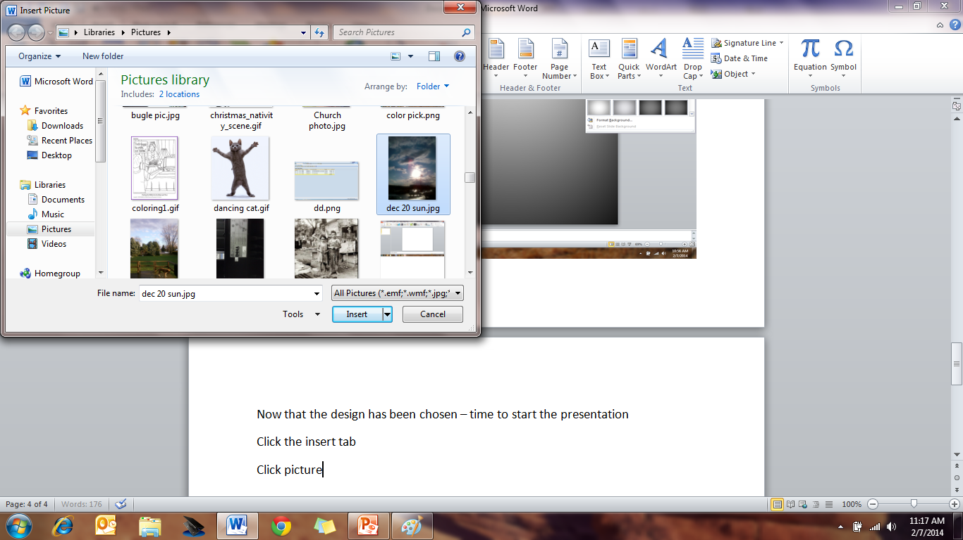
Pick a picture
Click insert
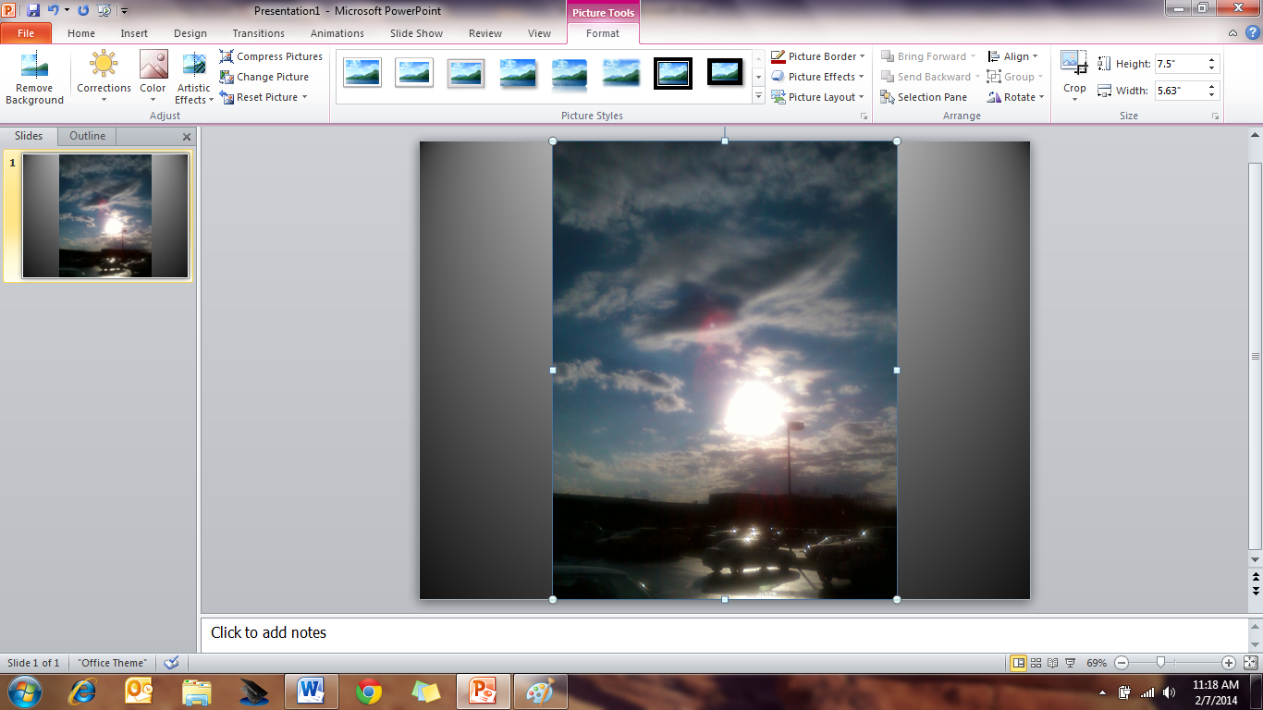
The picture will have 8 dots around the edge to adjust the picture
Move the mouse to the dot until it until it turns into a line with two point ends
Click the mouse and hold the line will turn into a cross
While holding the mouse click down move left right up or down to adjust the picture to the size you like
Clicking the green dot if you wish to rotate the picture
Move the picture into the desired location
Click in the center of the picture
Hold the mouse click down and drag the picture to the desired position

There are many design features for a picture
This example
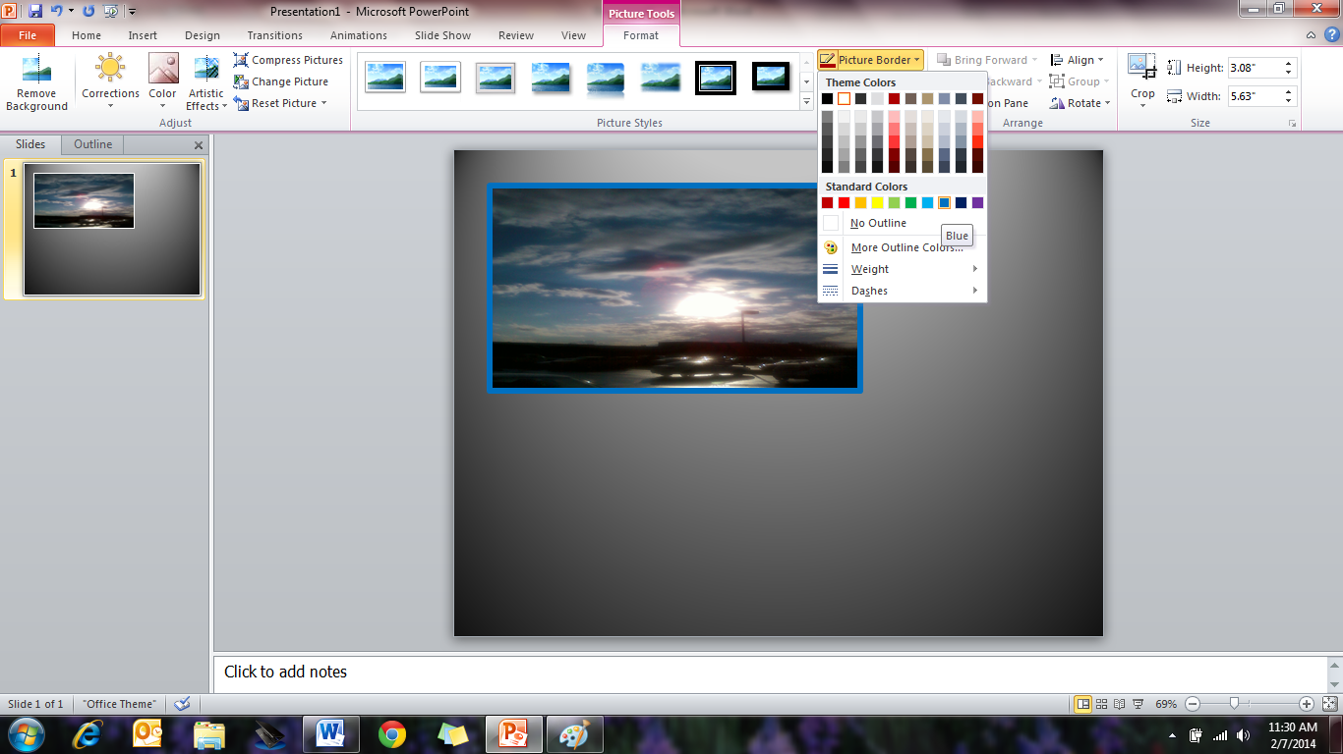
I chose the picture border of blue and on the same tab the weight of 6
If you don’t want to choose where to put a picture you can
Click picture layout
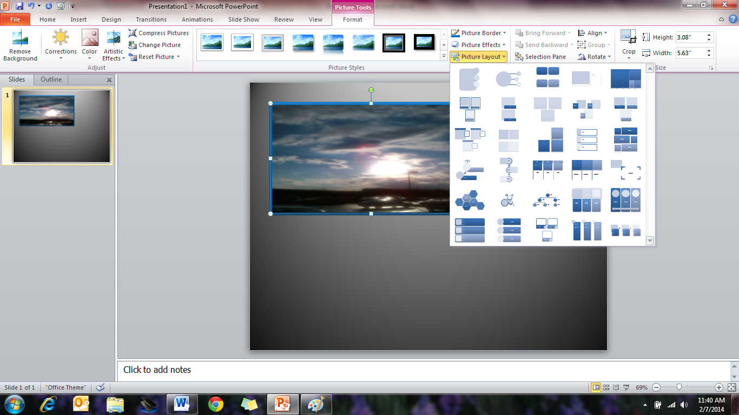
This option will automatically place your pictures for you – remember though to use pictures sparingly unless you are show casing an event.
Don’t like the picture - Click the center of picture and hit delete button
Click Insert
Clicktext box
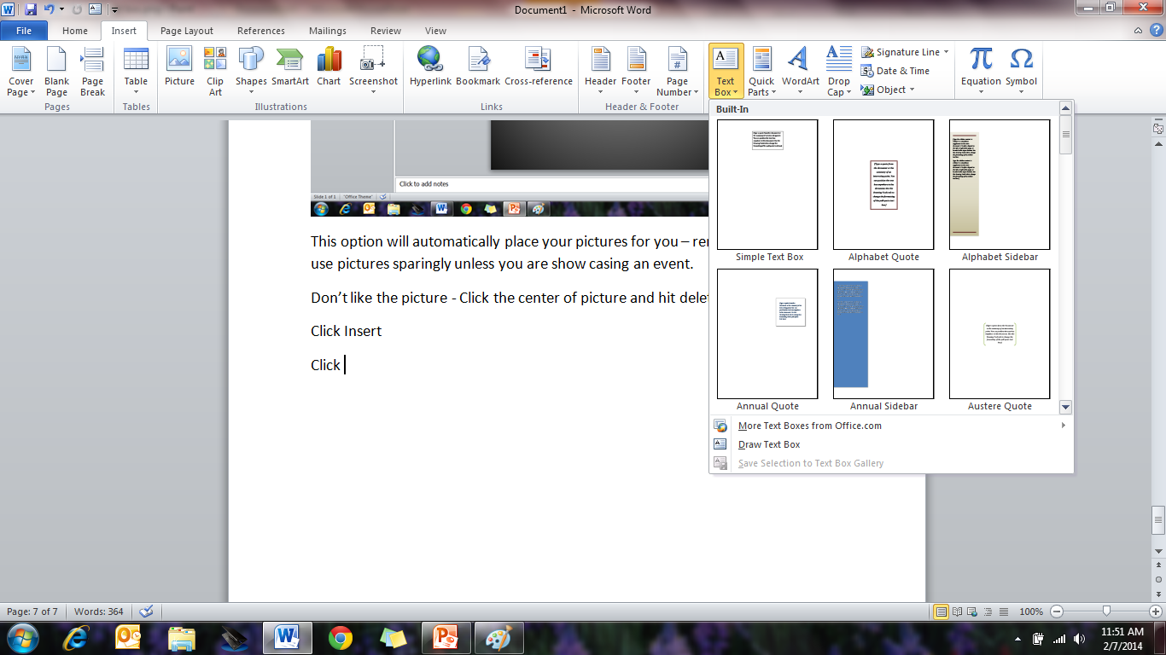
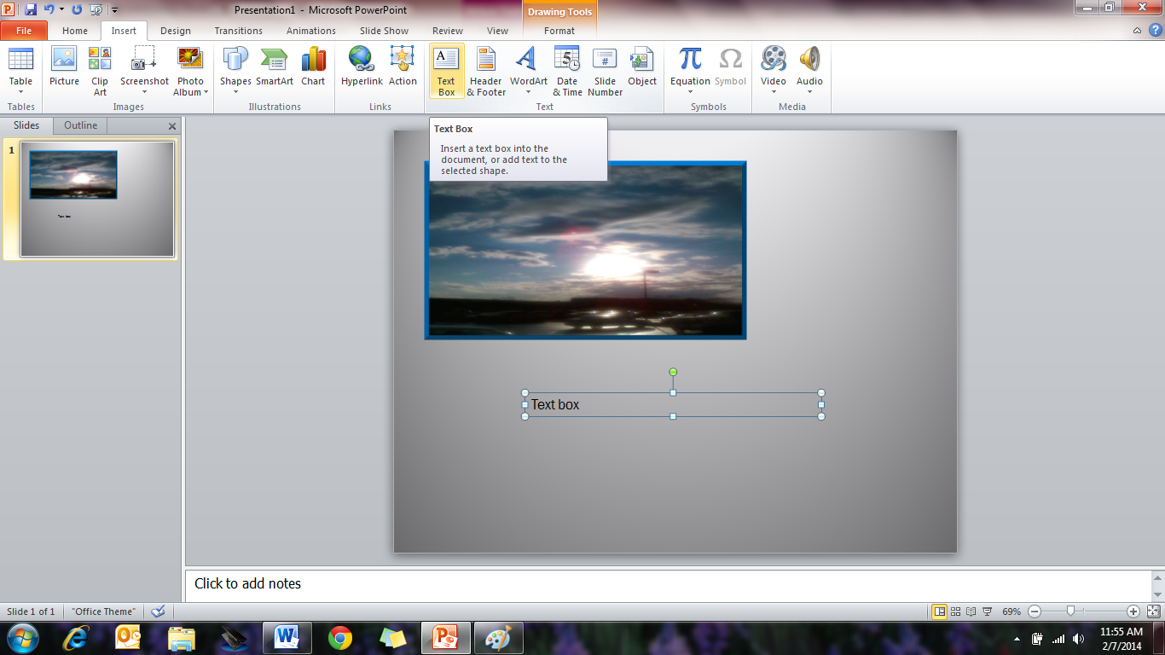
Click text box
Click on the page
Hold mouse down a cross will appear
Drag the mouse to the desired size of text box (You can resize after the text is entered if needed)
New Page
Click Home page
Click New Slide
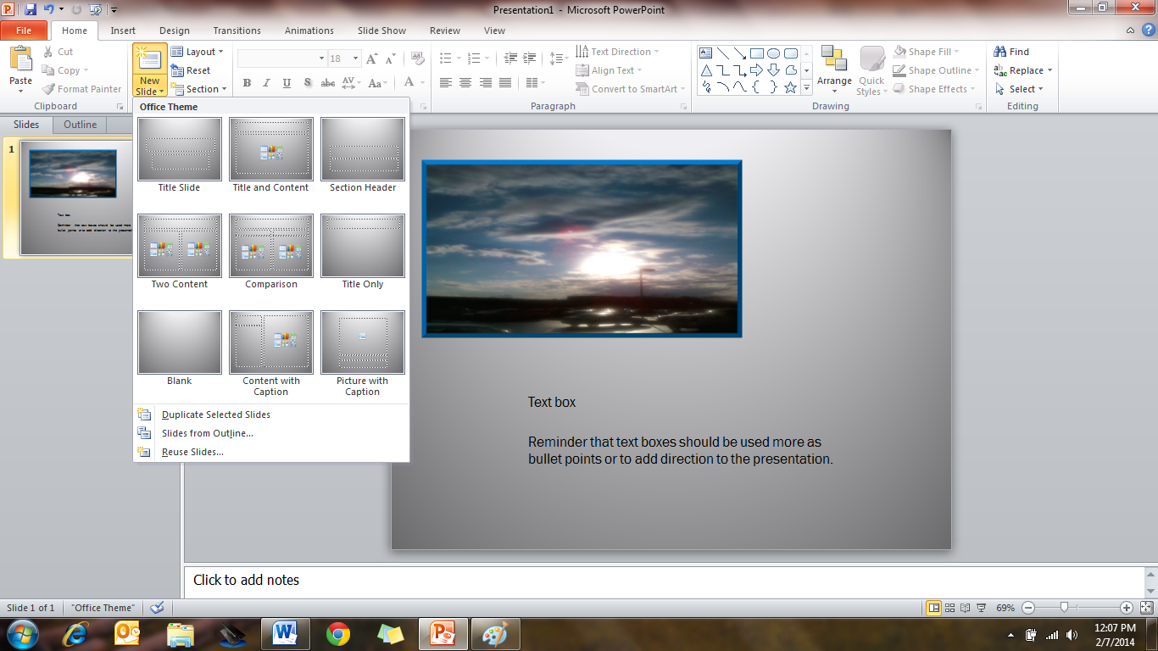
Choose a template or blank page – templates position text boxes and pictures for you.
Clip Art
Click Insert
Click Clip Art a new box will open
Type in the picture you are looking for (my example balloon)
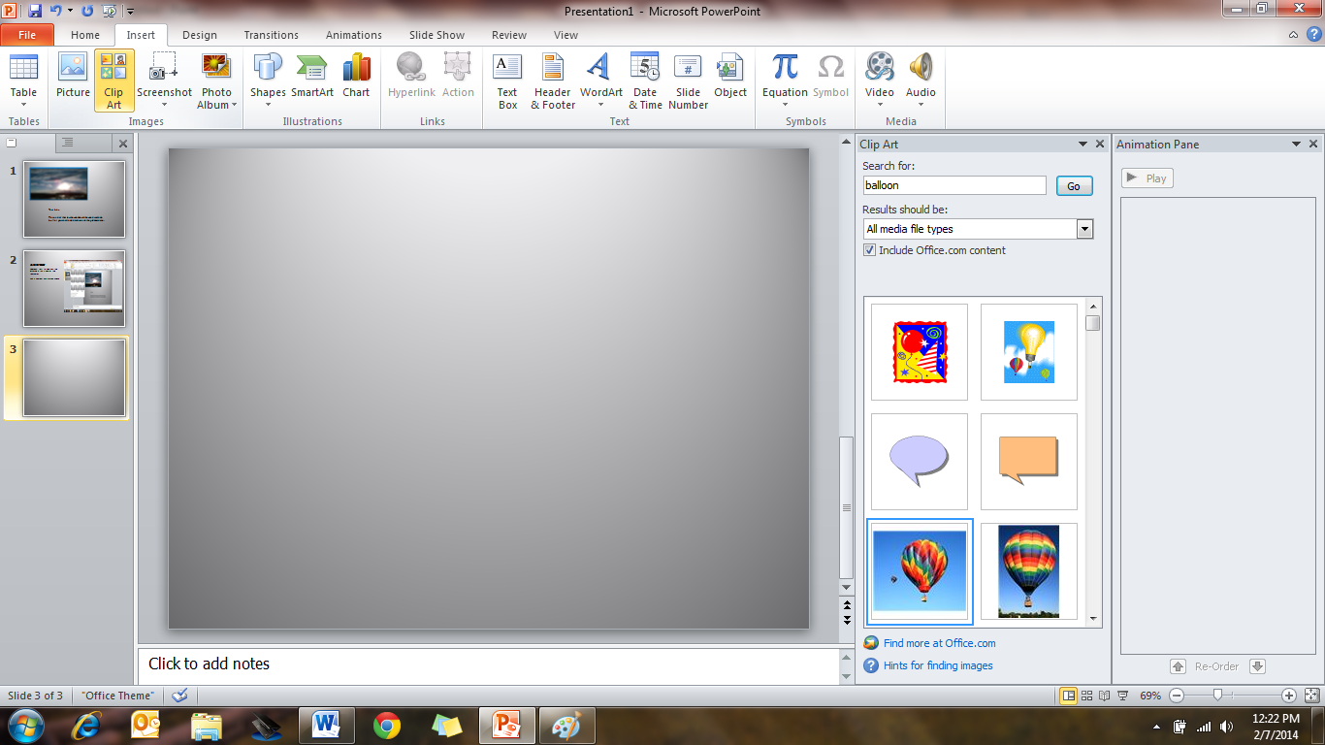
Scroll to the picture you like
Double click the picture
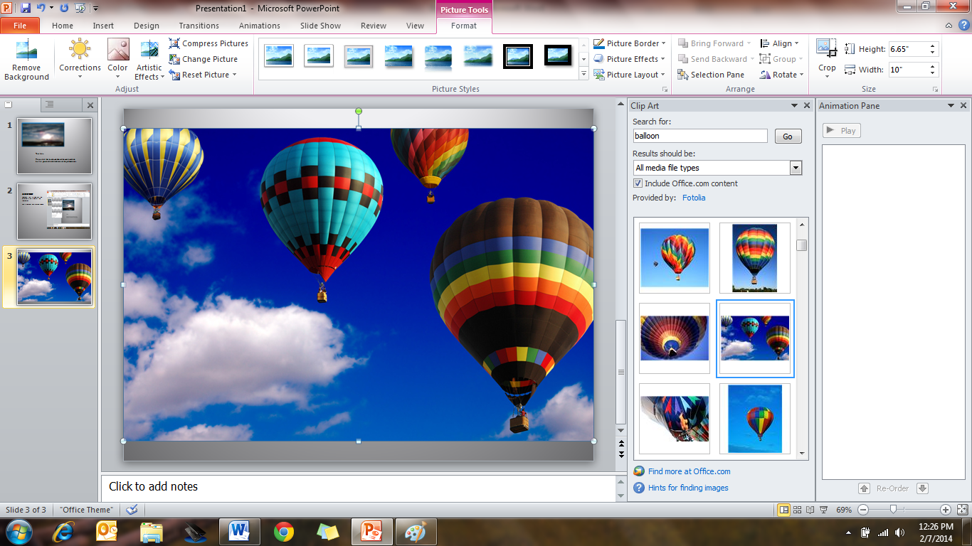
Click one of the dots and hold till the cross appears
Drag the mouse to resize the picture
Inserting a video
I found Ilivid software on line that seems to be the easiest and fastest way to download a video from Youtube or other source. Once you have installed the software all you do is copy and paste the URL and the file will go into your download directory.
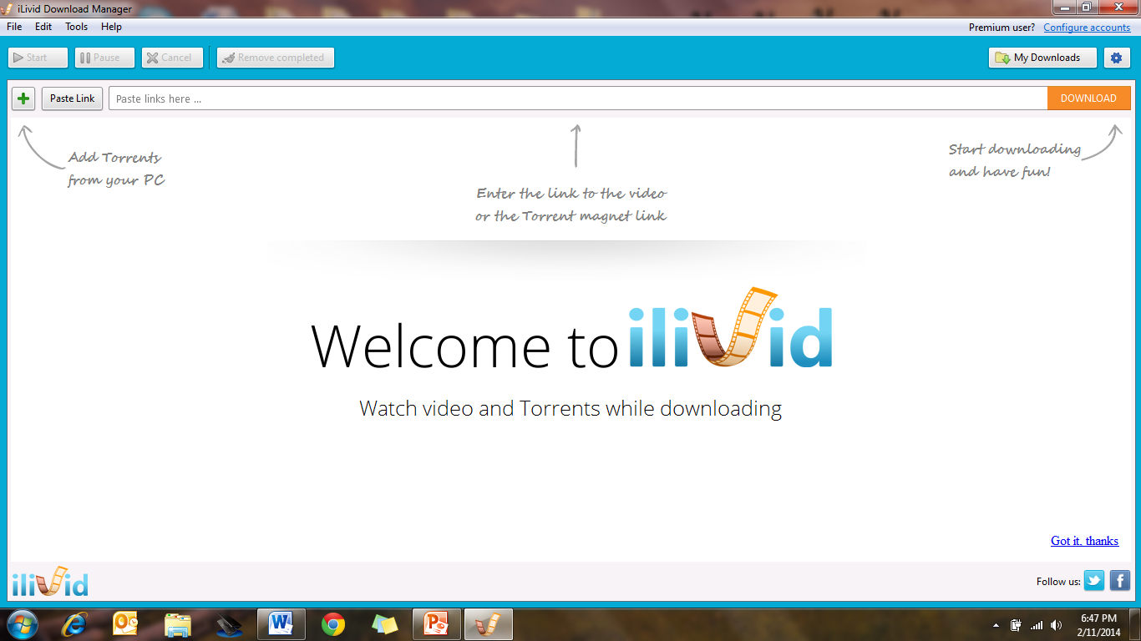
I am adding these instructions for downloading the file / video
Go to Youtube and search for the file you would like
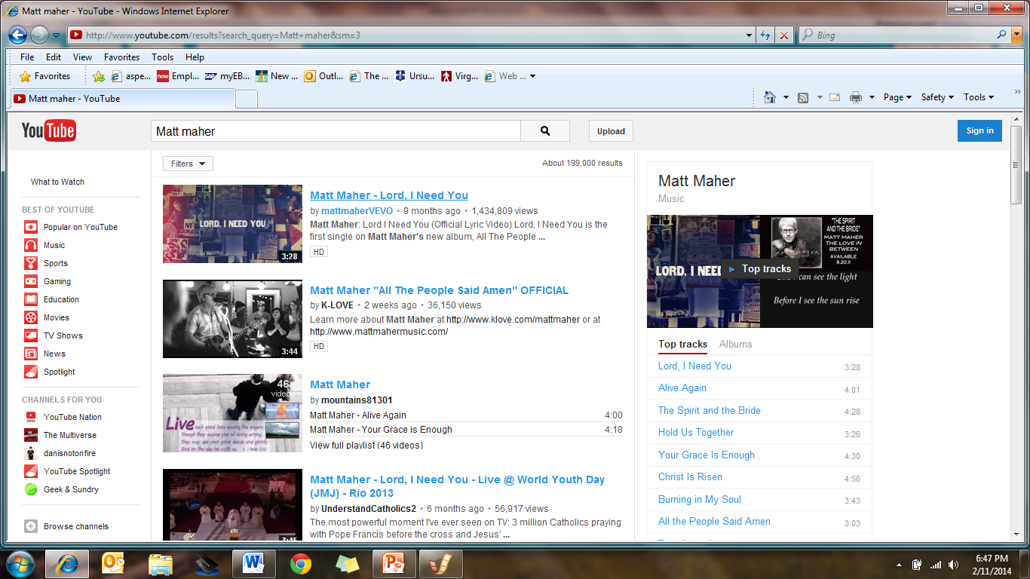
Double clickon your selection and it will begin to play.
Highlight the address line (URL) as shown at the top of this picture
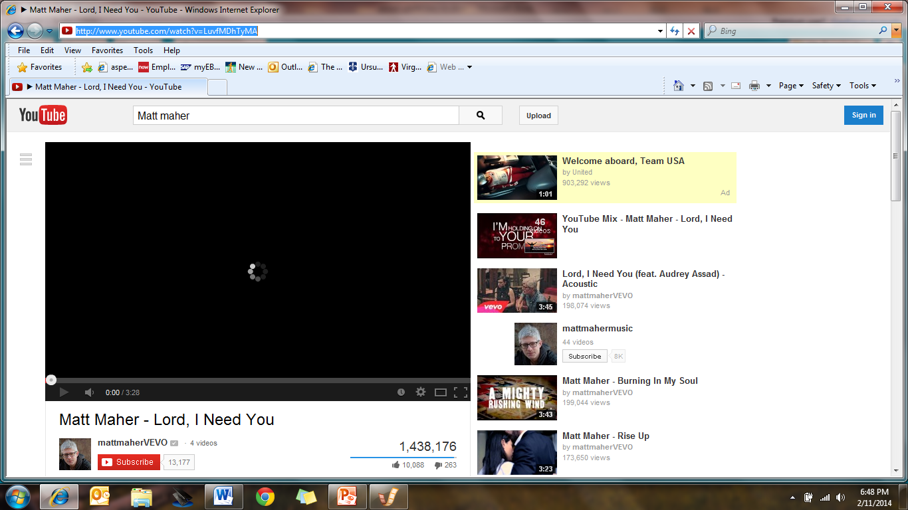
Right clickin the address bar
Click copy
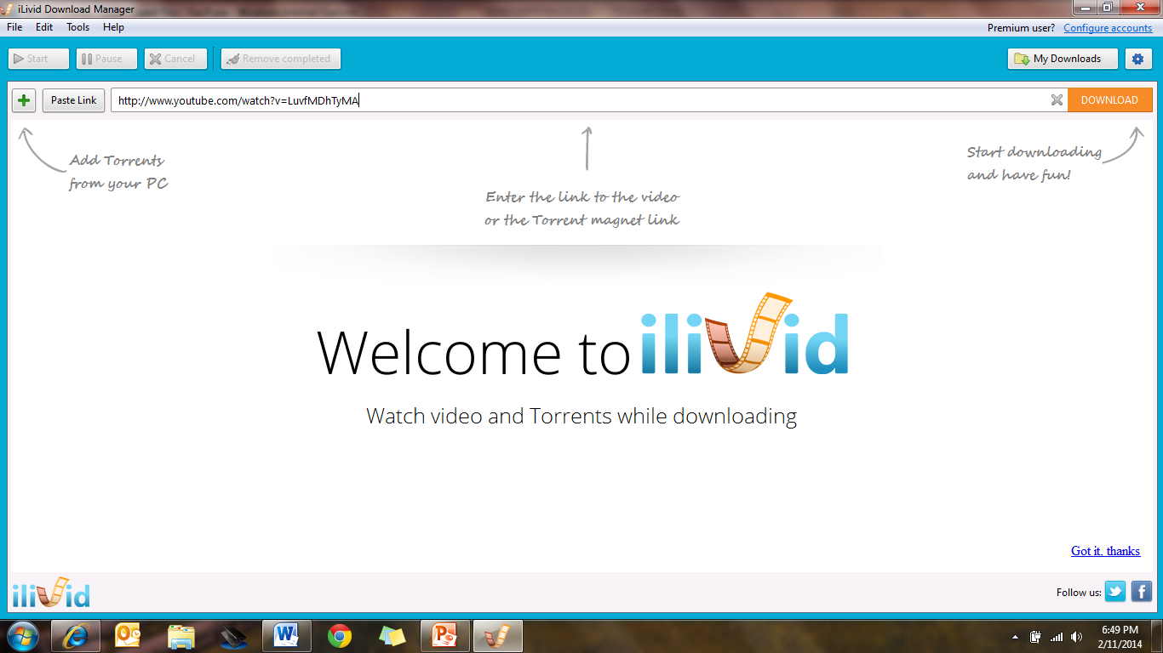
Right clickinside the download bar on ilivid
Click Paste
Click download

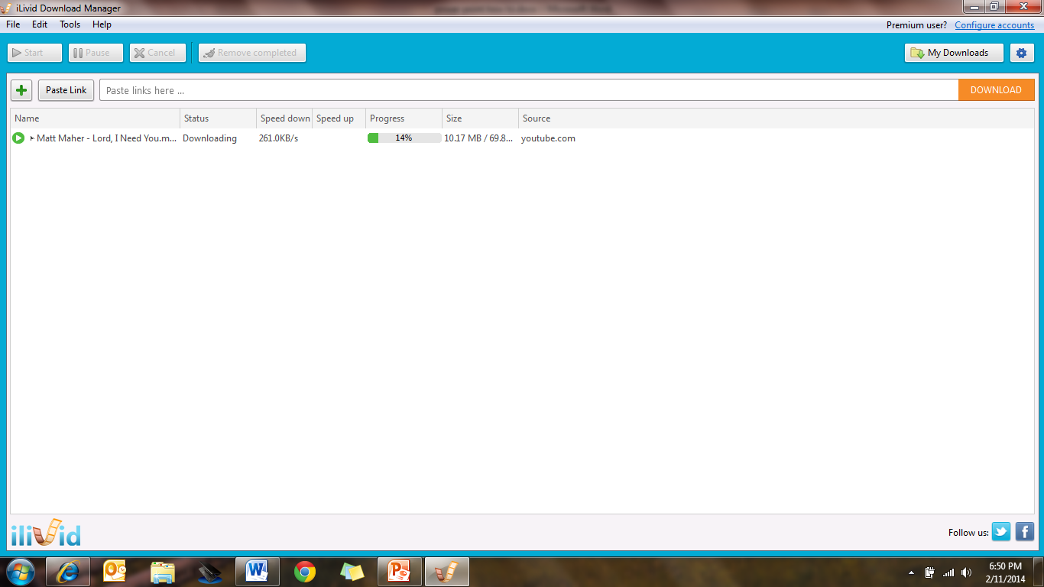
Once the file is 100%
ClickMy Downloads
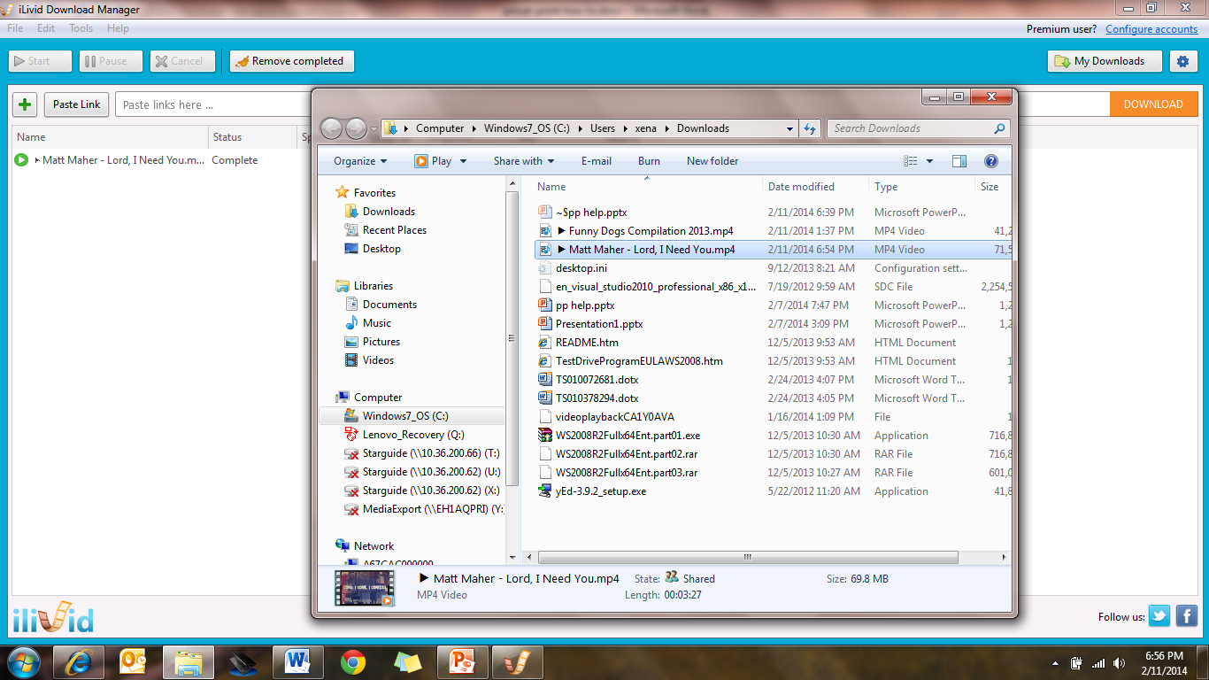
Your download directory will appear (write down the path if you are unsure when Ilivid is closed.)
Back to the power point directions
Click Insert
Click Video
Click from a file
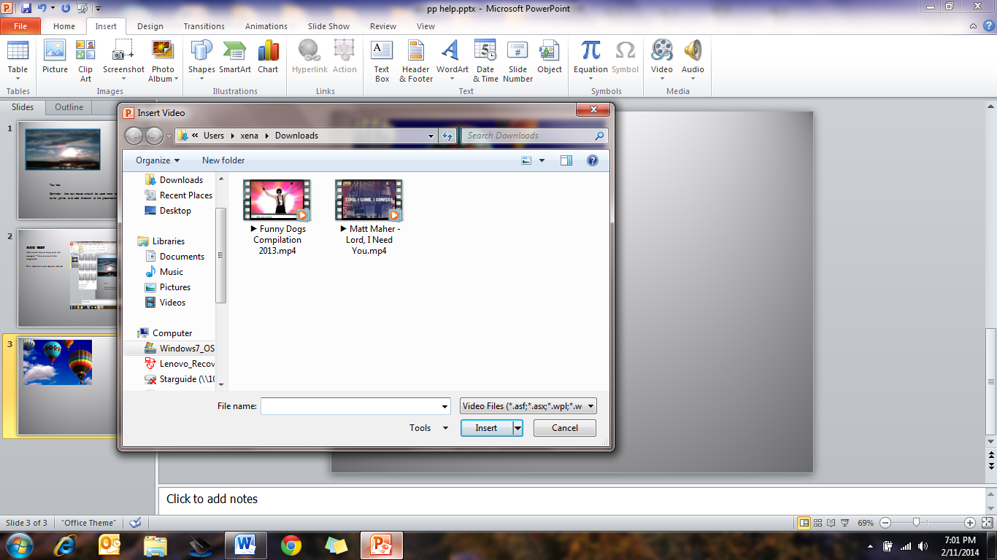
Double Click on your selected video
Power point should go directly to your downloads directory if it does not you can follow your path to the downloads
Your video will appear as a black box on the page – position the mouse in the bottom left corner of the box and you will see a right pointing arrow - click to confirm your video plays
Add Animation Action(this is helpful so the video starts playing when you go to the page)
Click Animations Tab
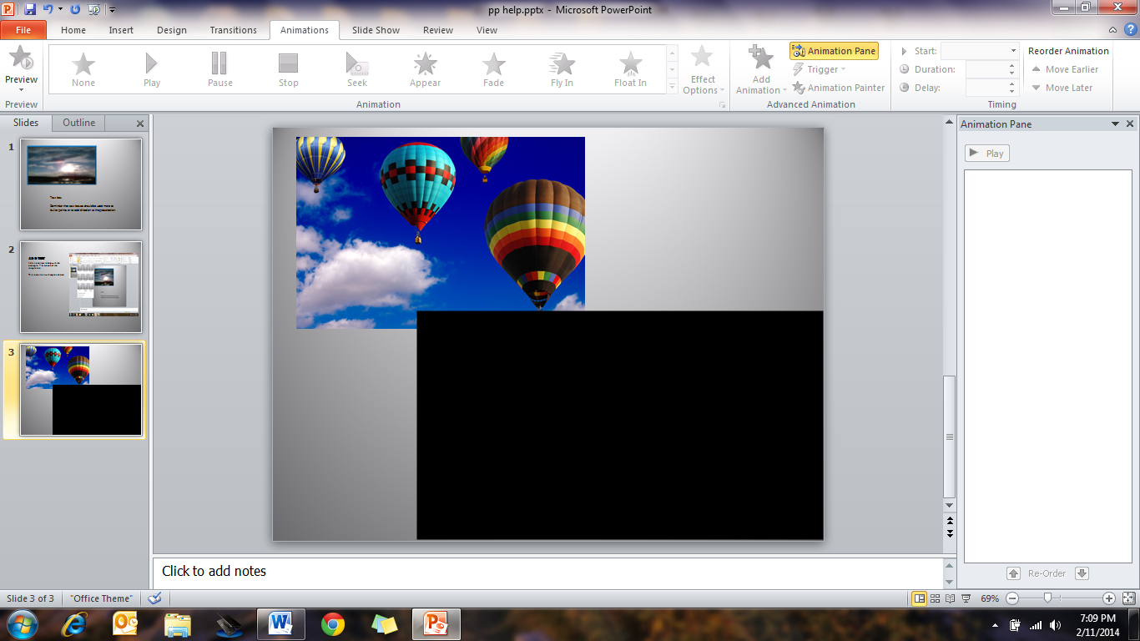
Click animation pane
A little window will open on the right
Click in the center of the video
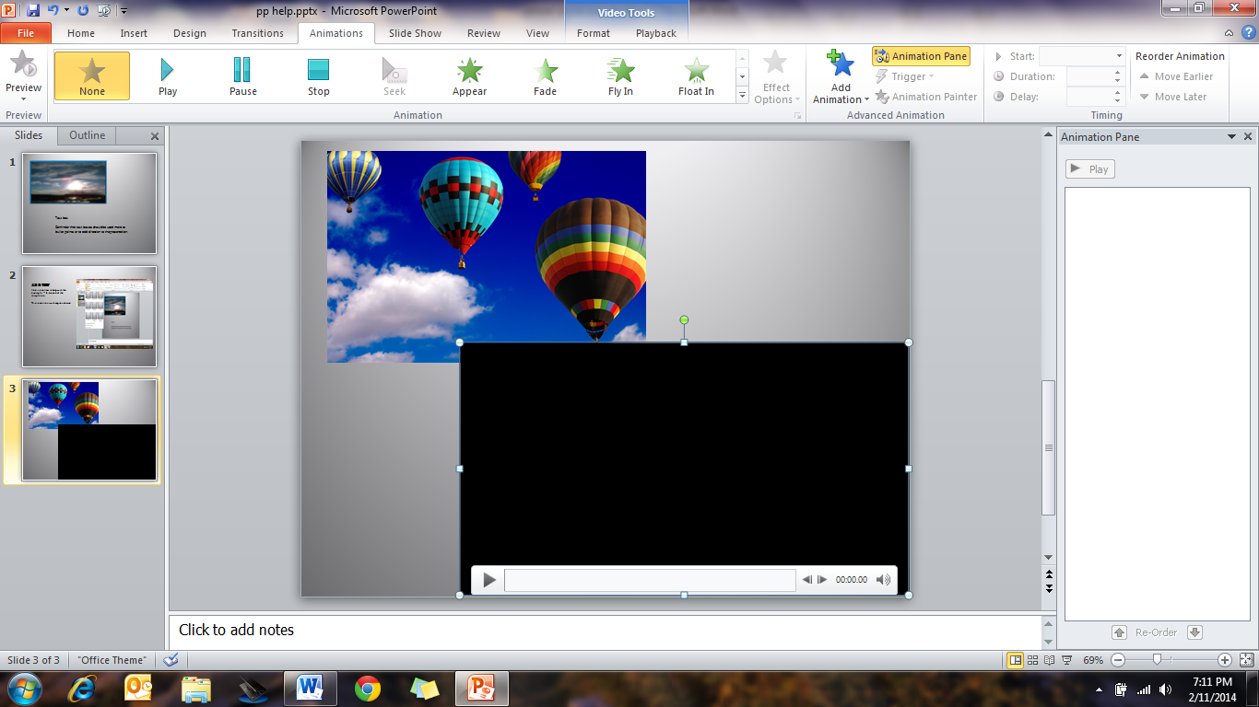
Click the play button
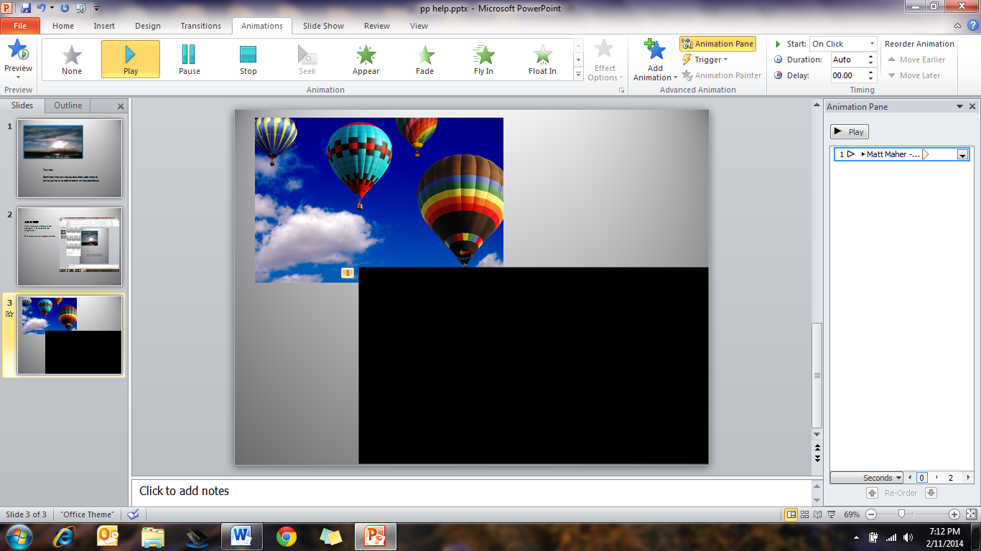
Click on the down arrow beside the video name
Click start after previous
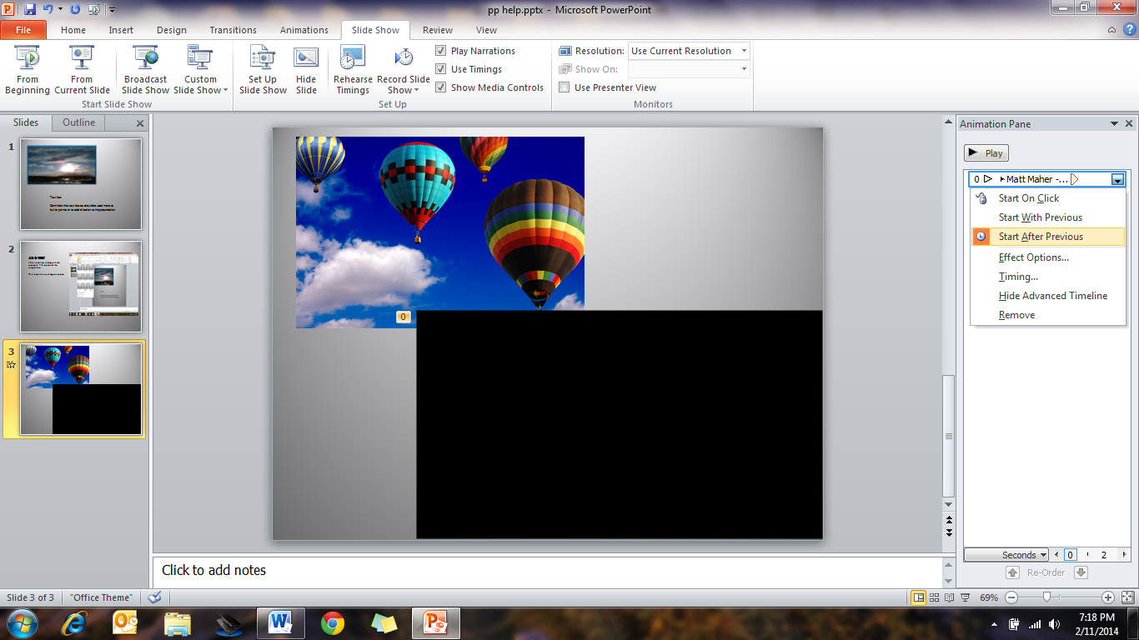
This will start the video when the slide is entered

How to add a transition
Click the transition tab
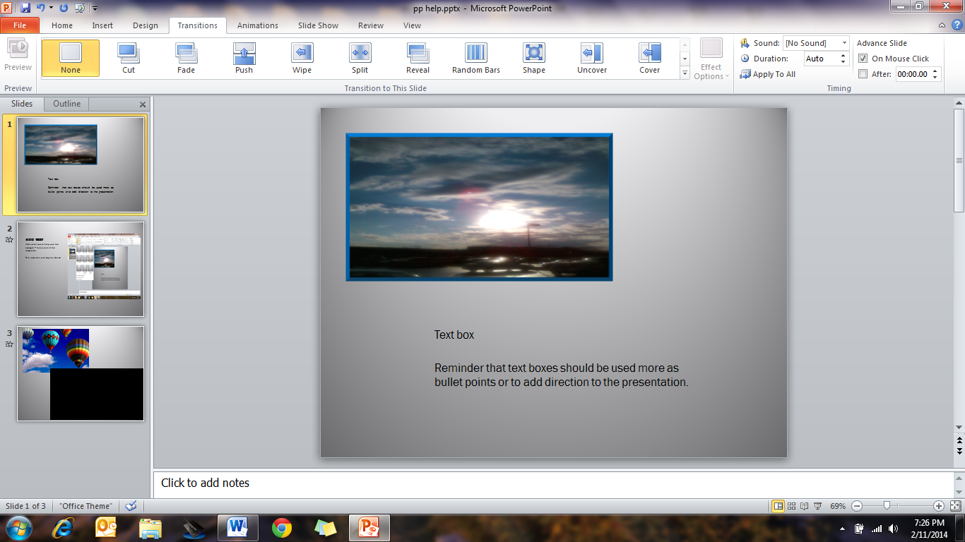
Click the down arrow with the line on the right side of the transition possibilities to see all available.
Click your selection
Click apply to all (if you want to have the same transition)
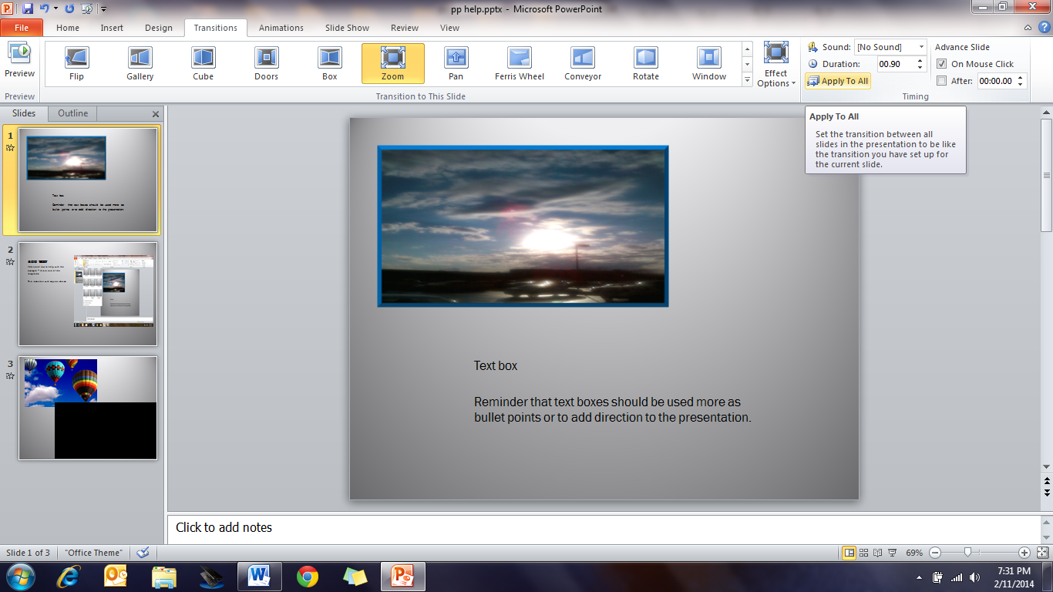
If you wish to have different transitions
Click each slide page
Click the transition of your choice
How to insert an audio file
Click Insert Tab
Click Audio
When the window opens it should go to your music directory
If it does not navigate to your chosen audio file
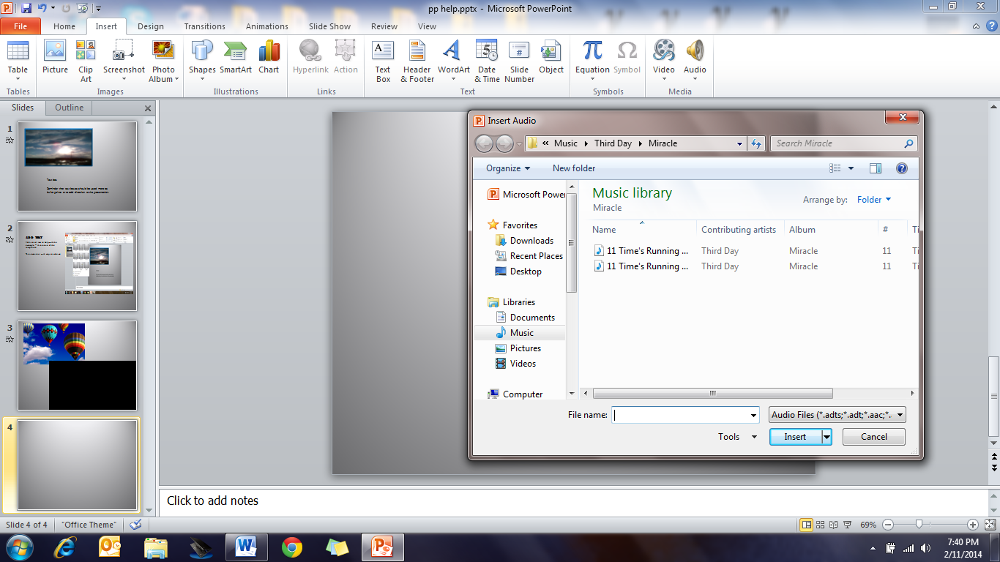
Double click your selection
Return to the Add Animation section – if you want to have the piece play when entering the slide or on a click
To add an Animation File Known as a .GIF
Search for .GIF files (GIFBin.com) has a good selection of free files or type in subject (space) .GIF in your search bar
Right clickon image
Click save (be sure the file extension is .gif)
Open your picture directory
Right Clickthe image
Click Copy
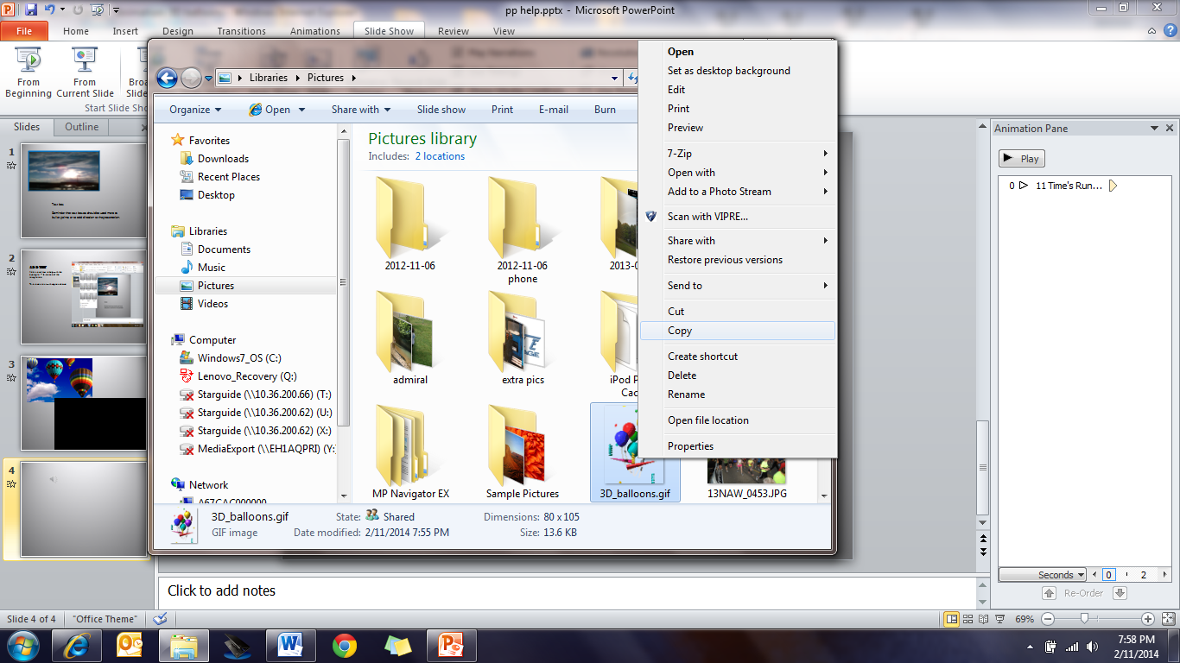
Click on the slide
Right Click
Click Paste
Resize by clicking one of the dots
To View your work
Click Slideshow Tab
Click play from beginning or current slide
There is so much more you can do with power point – just keep clicking!

