Using Dropbox
Diocesan Technology Seminar • 16 January 2014
Carmen Roebke • croebke@kent.edu

Set up your account
Go to www.dropbox.com. Register your name and e-mail. Establish a password.
Option to download application
to your computer
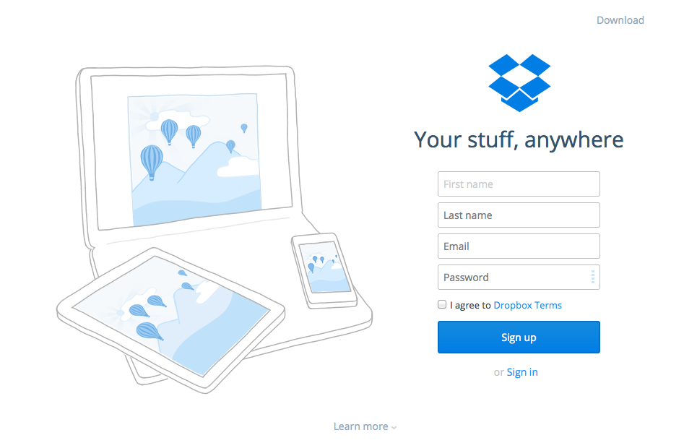

Your Home Page
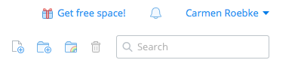Upload, create a new folder, share folders

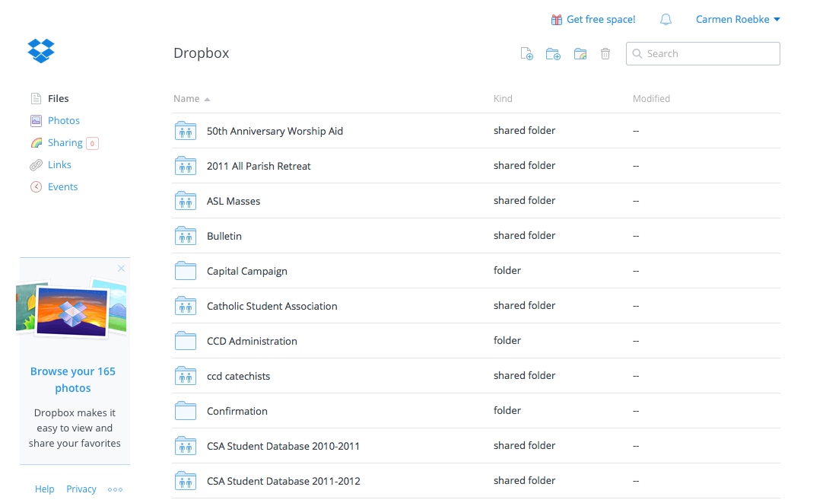

Sharing Folders
Click on Sharing icon on top right of home page:

Your list of folders will come up. Select the folder you would like to share.

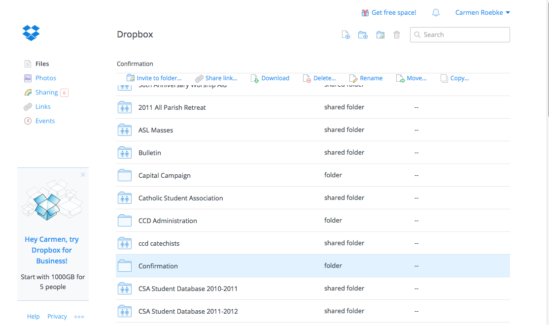
File options appear at top
Selected file

A dialogue box will appear. Type in the e-mail address of the intended recipient.
If you have established a contacts list in Dropbox, a name will bring up the e-mail address.

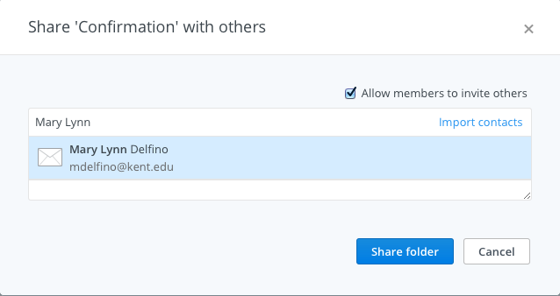
This is the default setting. If you want total control over who has access to the file, deselect this.

Un-sharing folders
On your home page, select folder that you wish to un-share. Click on “Shared folder options:
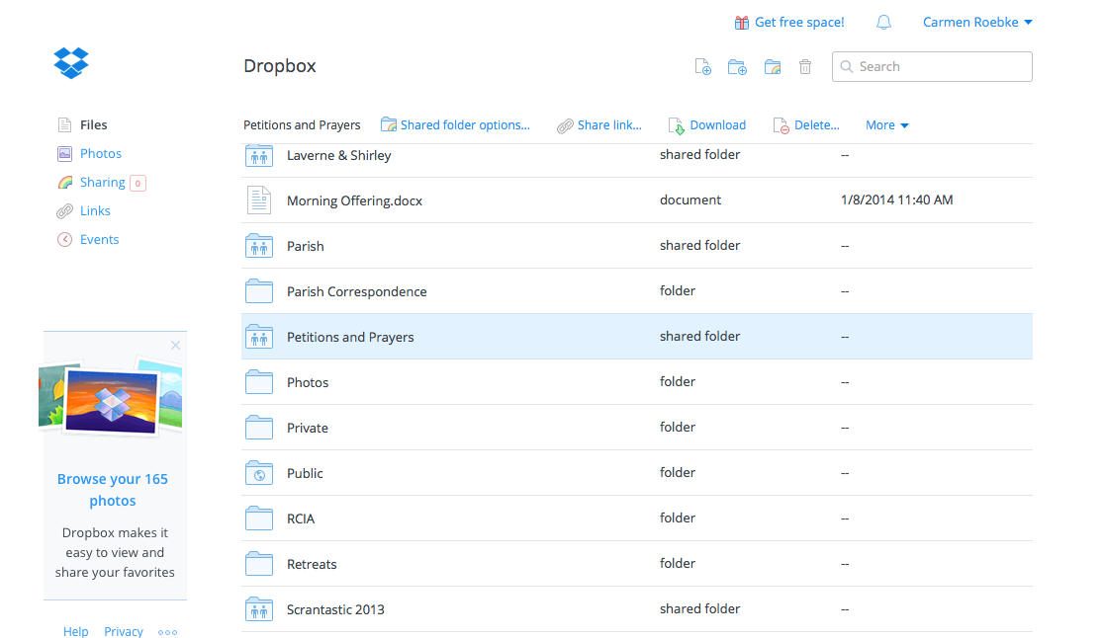
Selected file
File options appear at top

A dialogue box will come up. Click on the gear following the person you wish to remove. Another dialogue box will come up. Select desired action.
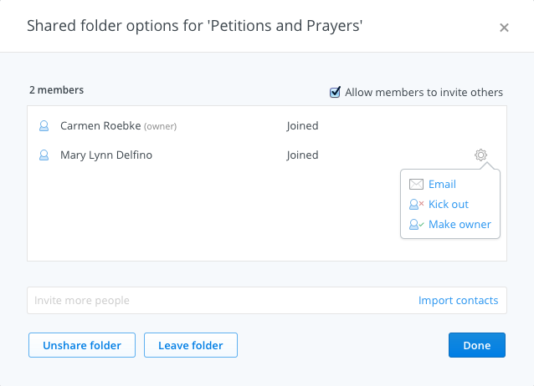
On Your Computer

